ENGF0003 Coursework

Table of Contents
Model 1 3
Introduction 3
Methods 3
Conclusion 4
Model 2 5
Introduction 5
Methods 5
Conclusion 6
Model 3 7
Introduction 7
Methods 7
Conclusion 9
Model 4 10
Introduction 10
Methods 10
Conclusion 12
Model 5 13
Introduction 13
Methods 13
Conclusion 15
Summary 16

Model 1

Introduction
An ideal gas is a gas defined as to have molecules that are small spheres with negligible volume which do not interact unless they collide with one another elastically. The ideal gas law is:
$$P(ρ)=ρRT$$
(1)
Where $P$ is the pressure [Pa], $ρ$ is the density [kg m⁻³], $R=287.053$ [J kg⁻¹K⁻¹] is the universal gas constant and $T$ is the temperature of the gas [K]. Pressure in this case is directly proportional to the density of the gas.

Methods
Suppose we change the density from $ρ_{0}$ to $ρ$ by $Δρ$:
$$Δρ= {ρ-ρ}_{0}$$
(2)
The pressure would change by:
$$ΔP=P\left(ρ_{0}+ρ\right)-P(ρ_{0})$$
(3)
We can re-write Eq. 3 by evaluating the two different densities to Eq. 1.
$$ΔP=\left(ρ_{0}+Δρ\right)RT-ρ_{0}RT ⇔ΔP=ΔρRT$$
$$⇔ \frac{ΔP}{Δρ}=RT$$
(4)

If we suppose that at sea-level conditions the density of air is $ρ_{0}=1.225 kgm^{-3}$ and $T=288.15 K$ and our changes in density are $Δρ=0.5, 0.25, 0.1, 0.05 and 0.01$. The five different pressures will be:
$$P\left(ρ_{0}+0.5\right)=142.68221 kPa,$$
$$P\left(ρ_{0}+0.25\right)=122.00362 kPa$$
$$P\left(ρ_{0}+0.1\right)=109.59648 kPa$$
$$P\left(ρ_{0}+0.05\right)= 105.46076 kPa$$
$$P\left(ρ_{0}+0.01\right)= 102.15219 kPa$$
Now, if we evaluate the change between the increasing pressures, we will see that:
$\frac{ΔP}{Δρ}=\frac{P{(ρ}_{0}+0.05)-P{(ρ}_{0}+0.01)}{{(ρ}_{0}+0.05)-{(ρ}_{0}+0.01)}$ = 82714.25 Jkg⁻¹
$\frac{ΔP}{Δρ}=\frac{P{(ρ}_{0}+0.1)-P{(ρ}_{0}+0.05)}{{(ρ}_{0}+0.1)-{(ρ}_{0}+0.05)}$ = 82714.4 Jkg⁻¹
$\frac{ΔP}{Δρ}=\frac{P{(ρ}_{0}+0.25)-P{(ρ}_{0}+0.1)}{{(ρ}_{0}+0.25)-{(ρ}_{0}+0.1)}$ = 82714.26 Jkg⁻¹
$\frac{ΔP}{Δρ}=\frac{P{(ρ}_{0}+0.5)-P{(ρ}_{0}+0.25)}{{(ρ}_{0}+0.5)-{(ρ}_{0}+0.25)}$ = 82714.36 Jkg⁻¹
The change in pressure with respect to the changes in the density of air are approximately constant and equal to:
$RT=287.053*288.15=82714.32$Jkg⁻¹

Our linear equation therefore is:
 | $$P-P_{0}=\frac{ΔP}{Δρ}(ρ-ρ_{0})$$ | (5)

Where $\frac{ΔP}{Δρ}=82714.32 J{kg}^{-1}$, $P_{0}=101325 Pa$ and $ρ_{0}=1.225 kgm^{-3}$.
Our final linear equation is:
$$P\left(ρ\right)=82714.32ρ-0.042$$
As we reduce $Δρ$ from 0.5 to 0.01, the difference $ΔP$ decreases as well. We can see this in Eq. (5),
$\left(ρ-ρ_{0}\right)=Δρ$ and the finite change $\frac{ΔP}{Δρ}$ is a constant, therefore, $ΔP$ is proportional to $Δρ$.

Conclusion
As the density of air increases the pressure of air increases with a rate of change of $RT$. The density of air increases as the height from the sea-level increases, therefore, decreasing the pressure of air. A decrease in air pressure reduces a person’s oxygen uptake and may hinder aerobic performance. So, someone’s physical performance may not be as intense as it could be and recovery time increases. Therefore, a football player may not perform as well at places higher than a certain height above sea-level. Additionally, air resistance decreases as air density decreases due to the reduction in the collisions of air molecules with the moving body. However, the usual drag and lift moving bodies experience at lower heights changes thus decreases our sensorimotor skills. Sensorimotor skills are used subconsciously by people to gather information about what is happening around us using our senses to create certain responses, such as controlling a football which is falling on the ground. This would create an unfair advantage for the home team since they have developed sensorimotor skills for the location, they train in.

Model 2

Introduction
For this model we chose to investigate the atmospheric pressure by dividing space into very small cubes of dimensions $Δx*Δy*Δz$, as seem om Fig. (1). However, at small volumes the air density may vary significantly, but above a specific volume the density becomes stable. At that volume air at standard pressure and temperature can be expressed as a continuous medium. This is very precise for most engineering applications.
Figure 1: Represents the small cube of air

Methods
$W$ in Fig. (1) is the weight of the small cube. Knowing the weight, mass $[kg]$ and gravitational acceleration $[ms^{-2}]$ we can calculate the pressure exerted on the bottom face of the cube of air. The formula of pressure in $Pa$ is:
$$P=\frac{Force (F)}{Area (A)}$$
The force in this case is the weight of the air and the area it is acting on is the bottom face of the small cube of air.
 | $$ΔP=\frac{ΔW}{ΔA}=\frac{gΔm}{ΔxΔy}$$ | (6)
The volume of the small cube is equal to:
 | $$ΔV=Δx*Δy*Δz$$ | (7)
By rearranging Eq. (7) to find the value of $ΔxΔy$ we can substitute that value in Eq. (6) to get Eq. (8):
$$ΔP=\frac{gΔmΔz}{ΔV}⇔$$
 | $$⇔ \frac{ΔP}{Δz}=\frac{gΔm}{ΔV}$$ | (8)
To ensure this equation holds I will perform dimensional analysis. Dimensional analysis is identifying the physical quantity of a relationship of different quantities such as length, mass, etc. For an equation to hold we require dimensional homogeneity, which means the right-hand side (RHS) and the left-hand side (LHS) of an equation should have the same dimensions.
The RHS has of the equation has dimensions:
$$\frac{{kgms^{-2}}/{m^{2}}}{m}=kgm^{-2}s^{-2}$$
The LHS has dimensions:
$$\frac{ms^{-2}*kg}{m^{3}}=kgm^{-2}s^{-2}$$
The dimensions of the LHS and RHS are equal, thus, the equation holds.

Conclusion
We have expressed the finite change in the pressure $ΔP$ acting on the bottom face of the cube with respects to the finite change in the height $Δz$ of the cube. However, what we really found was the finite change in atmospheric pressure $ΔP$ with respect to a finite change in altitude $Δz$. Diving space into small cubes made the representation of the theoretical framework simpler and clearer. This allows engineers to analyse a real-world scenario clearer, therefore, be able to provide suitable solutions.

Model 3

Introduction
The air in our atmosphere is a static and incompressible fluid. This means the fluid is not moving. This is possible because the fluid is experiencing ideally the same force from all directions. Therefore, density in a static fluid stays constant since the fluid does not move. Practically however, the density of air is not constant, however, for simplicity we will assume it stays constant. We will also assume the gravitational acceleration is constant with a change in altitude. Under some assumptions made to the computation of a differential fluid element of mass to obtain an equation for calculating the pressure field in a static fluid it is proven that the pressure is independent of the spatial coordinated $x$ and $y$ but only dependent on $z$, the elevation. Therefore, we are interested in knowing the change in pressure due to altitude changes in a static fluid. The equation obtained was the total derivative:
 | $$\frac{dP}{dz}=-ρg$$ | (8)

Methods
P is the atmospheric pressure in $Pa,$ $z$is the altitude from the ground in $m$, $ρ$ is the density of the fluid in $kgm^{-3}$ and $g$ is the gravitational acceleration in $ms^{-2}$. A more detailed unit of the pressure is: $kgm^{-1}s^{-2}$ using the formula of pressure, $\frac{\left(F\right) Force}{\left(A\right) Area}$ and Newton’s second law of motion, $F=ma$.
We can test if this equation holds through dimensional analysis.
The LHS of the equation has units:
$$kgm^{-1}s^{-2}{*m}^{-1}=kgm^{-2}s^{-2}$$
And the RHS has units:
$$kgm^{-3}*ms^{-2}=kgm^{-2}s^{-2}$$
Since, the units of the RHS is equal to the units of the LHS this equation holds.
As explained previously, the density and gravitational acceleration is assumed to be constant, therefore, the total derivative is constant. To find the function of atmospheric pressure in terms of altitude we need to integrate Eq. (8). However, we may also calculate the desired function through Riemann summation.
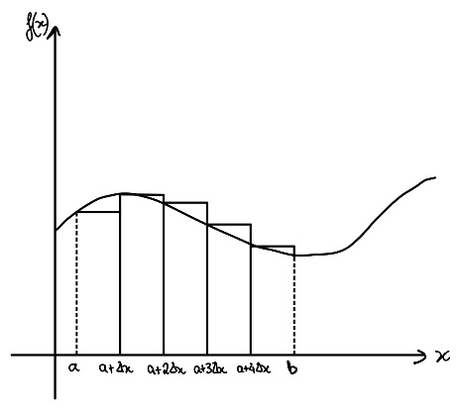
The general function of a Riemann sum is:
$\lim_{n⇾∞}{\sum_{i=0}^{n}{Δx*f(Δx_{i})}}$

Figure 2: Graph sketch of a Riemann sum

Where the interval Δx is, as shown in Fig. (1):
$$Δx=\frac{b-a}{n}$$
The Riemann sum in this case will be evaluated from the reference level $z_{0}=0$ at $P_{0}$ until an arbitrary z elevation at $P=P_{0}-ΔP$. Fig. (2) helps us understand that the pressure varies with a change in altitude. The Riemann sum would be:
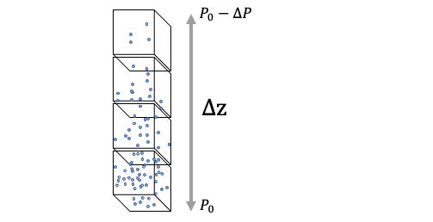
$P\left(z\right)-P_{o}=\lim_{n⇾∞}{\sum_{i=0}^{n}{Δz*\frac{dP}{dz}}}⇔$
$$⇔P\left(z\right)-P_{o}=\lim_{n⇾∞}{\sum_{i=0}^{n}{\frac{z-z_{0}}{n}*\left(-ρg\right)}}⇔$$
The variable $i$ is not in the summation so the variable $z$ and the constants can be moved outside of the summation.
$$⇔P\left(z\right)-P_{o}=\lim_{n→∞}{\frac{z-z_{0}}{n}*\left(-ρg\right)\sum_{i=0}^{n}{1}}⇔$$
The sum of a constant from 1 to n is simply equal to the number of increments between the summation limits, n. Therefore, the Riemann sum may be written as:
Figure 3: Schematic showing a simplified example of the air in the atmosphere
$$⇔P\left(z\right)-P_{o}=\lim_{n→∞}{\frac{z}{n}*\left(-ρg\right)*n}$$
The n’s cancel out so the limit as n approaches infinity for a function which does not depend on n is simply equal to:
 | $$P\left(z\right)=P_{o}-ρgz$$ | (9)

This function is a straight line with gradient equal to $-ρg$ suggesting that as the altitude increases the atmospheric pressure decreases from the initial reference value of $P_{o}$, as shown in Graph 1.
z = [0:1:10];
P = 101325-(1.204*9.81).*z;
plot(z,P,'-o');
grid on
xlabel('Altitude (m)')
ylabel('Atmospheric pressure (Pa)')
title('Atmospheric pressure against altitude')

Graph 1: graphical representation of the Eq. (6)

If we performed definite integration on Eq. (8) we would firstly multiply each side of the equation with $dz$ and get, since it is a separable homogeneous differential equation:
$$dP=-ρgdz$$
Then, we would integrate the LHS with a lower limit of $P_{0}$ and upper limit of $P$. For the RHS we would integrate with a lower limit of $z_{0}$ and an upper limit of $z$.
$$\int_{P_{0}}^{P}{dP}=\int_{z_{0}}^{z}{-ρgdz}$$
Then we would integrate both sides and simplify the equation:
$$P-P_{0}=-ρg\left(z-z_{0}\right)⇔$$
$$⇔P\left(z\right)=P_{0}-ρgz$$
Which is the same function we found when using a Riemann sum. We chose the specific limits for the RHS of the integration because, for our lower limit, our reference level is at zero altitude $z_{0}$and, for our upper limit, we are trying to find a function of the pressure with respect to the altitude to be able to find the pressure at any altitude, and not just one specific altitude. Thus, we chose as our upper limit the variable $z$. The same concept applies for the LHS. The atmospheric pressure at the reference level is $P_{0}=1 atm$, so our lower limit is $P_{0}$ and the upper limit is the pressure at the unknown altitude $z$.

Conclusion
The function that relates the pressure of the fluid with the elevation has many useful applications. For example, constructing a dam on a lake requires us to know the pressure exerted on its walls at every depth. Utilizing the function, we can see that the size of a dam does not depend on the horizontal length of a lake or a river, it depends only on the depth of the lake or river, therefore, allowing engineers the ability to understand how they are supposed to build a safe and reliable construction.

Model 4

Introduction
Atmospheric pressure may change indirectly through temperature and altitude. For example, a temperature increase, increases the volume of a fluid due to the increase in kinetic energy of the fluid particles and thus increase in vibration. Therefore, the fluid expands. An increase in volume of the fluid decreases its density since density is inversely proportional to the volume. Eq. (1) suggests that atmospheric pressure is proportional to the density of the air. Therefore, atmospheric pressure may change due to temperature. Moreover, we have concluded that atmospheric pressure may change also due to the altitude change. Eq. (9) suggests that an increase in altitude will cause the atmospheric pressure at that altitude to be lower than the atmospheric pressure at sea level. The rate at which atmospheric pressure varies with a change in altitude is described in Eq. (8).

Methods
We can combine these two equations which both describe changes to atmospheric pressure:
To recapitulate:
Eq. (1) is:
$$P=ρRT$$
And Eq. (8) is:
$$\frac{dP}{dz}=-ρg$$
We can rewrite Eq. (1) as:
$$ρ=\frac{P}{RT}$$
Now $ρ$ may be substituted with the rewritten equation above:
$$\frac{dP}{dz}=-\frac{Pg}{RT}⇔$$
$$⇔ dP=-P\frac{g}{RT}dz⇔$$
 | $$⇔ \frac{dP}{P}=-\frac{g}{RT}dz$$ | (10)
To conclude that this equation holds we need to perform dimensional analysis.
The LHS of the equation we can see that it is dimensionless since both variables in the numerator and denominator have the same dimensions of $kgm^{-1}s^{-2}$.
For the RHS we will have to calculate its dimensions:
$$\frac{ms^{-2}}{J*{kg}^{-1}*K^{-1}*K}*m=\frac{m^{2}s^{-2}}{kg*m^{2}*s^{-2}*{kg}^{-1}}=1$$
The RHS of the equation is also dimensionless, therefore, Eq. (10) holds.
Now we may investigate the effects of a change in altitude to the density of the air in the atmosphere.
To express the rate of change of the air in the atmosphere’s density with respect to an instantaneous change in the altitude we will have to integrate Eq. (10):
$$\int_{P_{0}}^{P}{\frac{dP}{P}=\int_{z_{0}}^{z}{\frac{-g}{RT}dz}}⇔$$
$$⇔ \ln{P}-\ln{P_{0}}=-\frac{g}{RT}\left(z-z_{0}\right)⇔$$
$z_{0}=0$ since we start at the reference level:
$$⇔\ln\left(\frac{P}{P_{0}}\right)=-\frac{g}{RT}z⇔$$
We can express the RHS of the equation with the use of logarithms with base $e$:
$$⇔ \ln\left(\frac{P}{P_{0}}\right)=\ln{{(e}^{-\frac{g}{RT}z})}⇔$$
The logarithm function is one-one, therefore, only one input matches with a specific output, therefore:
$$⇔ \frac{P}{P_{0}}=e^{-\frac{g}{RT}z}⇔$$
 | $$⇔P(z)=P_{0}e^{-\frac{g}{RT}z}$$ | (11)
From Eq. (1), we can substitute P for its equivalent:
$$ρRT=P_{0}e^{-\frac{g}{RT}z}$$
Now we can differentiate both sides of the equation with respect to the altitude $z$.
However, the RHS undergoes chain rule. We perform the chain rule when we have a composition of differentiable functions. In this case we have the functions:
$${f\left(z\right)=e}^{z}$$
And,
$$g\left(z\right)= -\frac{g}{RT}z$$
Then our function on the RHS of the equation is
$$h\left(z\right)=f(g\left(z\right))$$
The derivative of our function is simply:
$$h^{'}\left(z\right)=g^{'}\left(z\right)*f'(g\left(z\right))$$

$$\frac{dρRT}{dz}=P_{0}{\frac{1}{dz}e}^{-\frac{g}{RT}z}⇔$$
By following the chain rule, we differentiate both sides with $P_{0}, R and T$ being constants:
$$⇔ RT\frac{dρ}{dz}=P_{0}{\frac{-g}{RT}e}^{-\frac{g}{RT}z}⇔$$

 | $$⇔ \frac{dρ}{dz}=-\frac{gP_{0}}{{(RT)}^{2}}e^{-\frac{g}{RT}z}$$ | (12)
As the altitude increases, the rate of change of the density with respect to the altitude decreases since the exponential $e^{-\frac{g}{RT}z}$ decreases with an increase in $z.$

Conclusion
By combining the two ways in which atmospheric pressure changes, which is through temperature on the density of air and altitude which affects the weight of the column of air above a certain reference area $ΔxΔy$. The equation formed; Eq. (10) is a separable homogenous differential equation. By employing the chain rule, we obtained an expression for $\frac{dρ}{dz}$. This expression allows us to analyse the rate of change of air density due to an instantaneous change in altitude. Eq. (11) suggests that density will decrease at a decreasing rate as the altitude increases, since the exponential will approach zero as altitude approaches infinity. Therefore, since density affects the atmospheric pressure:
$$P=\frac{F}{A}=\frac{mg}{A}=\frac{ρVg}{A}$$
As altitude increases and density decreases, pressure will decrease as well since it is proportional to atmospheric pressure.

Model 5

Introduction
Models 1 to 4 have been focused on atmospheric pressure due to changes in density and altitude whilst assuming that the atmospheric temperature stays constant. This assumption was used in Eq. (1, 8 & 10). However, experimental measurements plotted in Graph 2 show that altitude also affects the atmosphere’s temperature. In this model we will investigate the effects of altitude on temperature up to 10 km in altitude from sea level. We will employ the expression of temperature as a function of altitude to solve Eq. (8 & 10). Then we will compare the results that we find for the case of a constant temperature and an altitude-dependent temperature in Eq. (10).

Methods
We have discussed how pressure varies to variations in altitude with the previously seen formula of:
$$\frac{dP}{dz}=-ρg$$
This happens because at different altitudes the gravitation force experienced by the air molecules due to the earth is different, for example, at higher altitudes air molecules experience a smaller force because they are at a larger distance away from the center of the earth. Therefore, those air molecules are not being compressed down due to the air molecules above them, thus air density is lower.
We have also encountered that the change in pressure with respect to altitude is related to the temperature of the air:
$$\frac{dP}{dz}=-\frac{Pg}{RT}$$
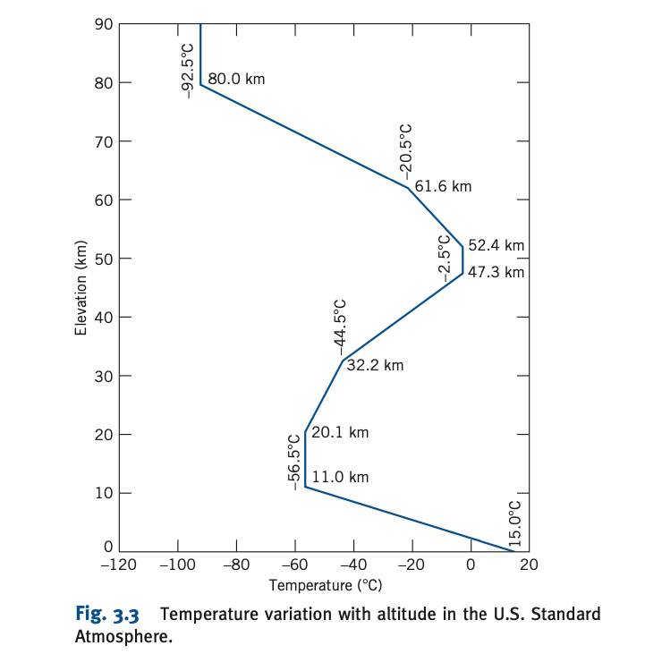
However, we also have the relation of altitude with temperature. At higher altitudes pressure decreases, a decrease in pressure leads to a decrease in temperature from Eq. (1). Since at lower pressures molecules will have a lower total kinetic energy and therefore the atmosphere’s temperature decreases. Fig. 1 shows how altitude affects the atmosphere’s temperature.
For an elevation of 10 km, we can express the temperature T as a function of the elevation (altitude) z where z is between 0 and 10 km.
From 0 to 10 km in altitude the temperature increases at a constant rate. We are given two coordinates which lie on that constant rate of change, $\left(11,-56.5\right) and \left(0,15\right):$
$$\frac{dT}{dz}=\frac{-56.5-15}{11000-0}=-6.5*{10}^{-3} °Cm^{-1}$$
So, the function $T\left(z\right)$ is:
$$T-15=\frac{dT}{dz}\left(z-0\right)⇔$$
$$T\left(z\right)=-6.5*{10}^{-3}z+15$$
(13)
We can now solve Eq. (8 & 10) by substituting Eq. (13) to both equations.
Graph 2: Graphical representation of the effect altitude change to the atmospheric temperature
$$\frac{dP}{dz}=-\frac{Pg}{RT} ⇔\frac{dP}{P}=\frac{-g}{RT}dz$$
$$⇔\frac{dP}{P}=\frac{-g}{R(-6.5*{10}^{-3}z+15)}dz$$
We can solve for pressure P by integrating the left-hand side from the pressure at the reference level $P_{0}$ to the pressure at a 10 km elevation $P$, and 0 to 10 km for the right-hand side:
 | $$\int_{P_{0}}^{P}{\frac{dP}{P}=\frac{-g}{R}\int_{0}^{10}{\frac{1}{-6.5*{10}^{-3}z+15}dz}}$$ | (14)

$$⇔\ln\left(P\right)-\ln\left(P_{0}\right)=\frac{-g}{R}\frac{1}{-6.5*{10}^{-3}}(ln\left|-6.5*{10}^{-3}*{10}^{3}+15\right|-ln\left|-6.5*0+15\right|) ⇔$$
By using logarithmic identities, we can simplify the equation:
$$⇔\ln\left(\frac{P}{P_{0}}\right)=\frac{g}{6.5*{10}^{-3}R}\left(\ln\left(\frac{17}{2}\right)-\ln\left(15\right)\right) ⇔$$
$$⇔\ln\left(\frac{P}{P_{0}}\right)=\frac{g}{6.5*{10}^{-3}R}\ln\left(\frac{17}{30}\right)⇔$$
$$⇔ \frac{P}{P_{0}}={(\frac{17}{30})}^{\frac{g}{6.5*{10}^{-3}R}}$$
Now we can insert the known values of $g \& R$:
$$P=P_{0}{\left(\frac{17}{30}\right)}^{\frac{9.81}{6.5*{10}^{-3}*287.053}} ⇔$$
$$⇔P=0.0505P_{0}$$
The pressure at the 10 km elevation is 0.0505 times the pressure at the reference level.
However, to describe the relationship between pressure and altitude, with the case that temperature is a constant, we get Eq. (12):
But when altitude depends on the temperature of the air, we use Eq. (14), upper limit of the integral in the RHS of the equation being a variable z, to obtain a function of pressure with respect to altitude.
$$\int_{P_{0}}^{P}{\frac{dP}{P}=\frac{-g}{R}\int_{0}^{z}{\frac{1}{-6.5*{10}^{-3}z+15}dz⇔}}$$
$$⇔ \ln{P}-\ln{P_{0}}=-\frac{g}{R}*\frac{-1}{6.5*{10}^{-3}}\left(\ln\left(-6.5*{10}^{-3}z+15\right)-\ln{(15}\right))⇔$$
$$⇔ \ln{\frac{P}{P_{0}}}=-\frac{g}{R}*\frac{-1}{6.5*{10}^{-3}}\left(\ln{\frac{-6.5*{10}^{-3}z+15}{15}}\right)⇔$$
$$⇔ \ln{\frac{P}{P_{0}}}=-\frac{g}{R}*\frac{-1}{6.5*{10}^{-3}}\left(ln({0.00043z+1})\right)$$

By using the fact that a logarithmic function is one-one we can simplify this equation using logarithmic identities.

$$\ln{\frac{P}{P_{0}}}=\ln{{\left(0.00043z+1\right)}^{\frac{g}{R}*\frac{-1}{6.5*{10}^{-3}}}⇔}$$
$$⇔\frac{P}{P_{0}}={\left(0.00043z+1\right)}^{\frac{g}{R}*\frac{-1}{6.5*{10}^{-3}}}⇔$$
 | $$⇔P(z)=P_{0}*{(0.00043z+1)}^{-5.25}$$ | (15)
For both Eq. (11 & 15) the atmospheric pressure decreases as the altitude increases, however, one function decreases more than the other. Eq. (11) decreases faster since it contains the variable at the exponent. We can see the rate of changes of both functions graphically.
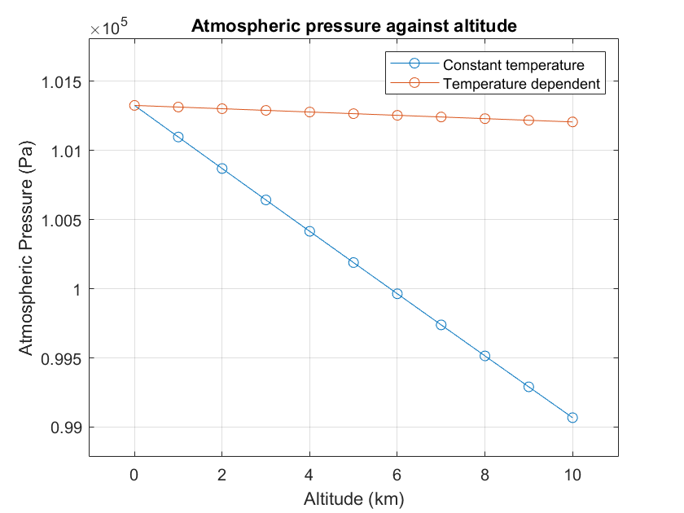
Graph 2: Graphical representation of pressure against altitude with constant and varied temperature

Conclusion
In Graph 2 we can see that the blue curve (pressure against altitude with constant temperature) decreases faster than the red curve (pressure against altitude with varied temperature). Therefore, by not considering the changes in atmospheric temperature our approximation for the atmospheric pressure at some altitude may not be accurate at all. In general, we need to consider the most important variables when forming conclusions for certain problems. The only variables we can neglect as engineers are the ones which have negligible contribution to the given problem.

Summary
By completing this piece of coursework, I have learnt more about pressure forces and the application o mathematics in real world scenarios. For example, by following the ‘Introduction to Fluid Mechanics’ by Fox and McDonald’s I learnt that the pressure at a certain depth or altitude is only affected by the altitude or depth and not the total dimensions of the space. Throughout the coursework I mainly used calculus to provide a solution. Calculus is a branch of pure mathematics, a deductive science and is an important tool for us as engineers. This coursework focused on a problem regarding football policymakers to understand the physical difference between playing sports at high and low altitudes. FIFA had temporarily banned football matches at altitudes above 2.5 km from sea level in 2007. In Graph 2 we can see (using the blue curve) that this is about 625 Pa less atmospheric pressure than at sea level, this is a considerably large difference in atmospheric pressure and may affect the potential of foreign football teams, since they have not been used to playing in these conditions. However, this was thought to be a discriminative decision thus the limit increased to 3 km. However, atmospheric pressure is not the only problem, humidity temperature and high levels of pollution are key problems at higher altitudes. Nevertheless, FIFA decided to remove this limit in football.

References

[3 & 5]“Introduction to Fluid Mechanics.” Fox And Mcdonald, 8th ed.
[4] Wikipedia contributors. “Dimensional Analysis.” Wikipedia, 26 Oct. 2022, en.wikipedia.org/wiki/Dimensional_analysis.
[6] Wikipedia contributors. “Chain Rule.” Wikipedia, 14 Oct. 2022, en.wikipedia.org/wiki/Chain_rule.
[7] ---. “High-altitude Football Controversy.” Wikipedia, 21 Dec. 2021, en.wikipedia.org/wiki/High-altitude_football_controversy.

https://pubmed.ncbi.nlm.nih.gov/18665955/
https://pubmed.ncbi.nlm.nih.gov/18665955/
Pritchard, P. J., & Mitchell, J. W. (2015). Fox and McDonald’s introduction to fluid mechanics (8th ed.). John Wiley & Sons. Chapter 2.1
https://en.wikipedia.org/wiki/Dimensional_analysis
Pritchard, P. J., & Mitchell, J. W. (2015). Fox and McDonald’s introduction to fluid mechanics (8th ed.). John Wiley & Sons
https://en.wikipedia.org/wiki/Chain_rule
https://en.wikipedia.org/wiki/High-altitude_football_controversy

